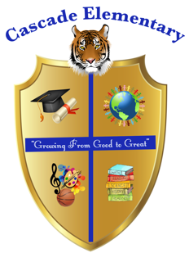

Cascade Elementary Website
Weekly Grade Level News Blast

Week of: Monday, March 30, 2020

Grade Level: Second Grade

Standards of the Week:
ELA: RI5: Use various text features.

MATH: G2: Partition a rectangle into rows and columns of same-size squares to find the total number of them.

SCIENCE: S2P1: Obtain, evaluate, and communicate information about the properties of matter and changes that occur in objects.

SOCIAL STUDIES: SS2H1: Describe the lives and contributions of historical figures in Georgia history.

Additional Information for Parents and Students:
There will be a slight change in how virtual learning will be implemented so stay tuned!

